**Standard Normal Distribution**

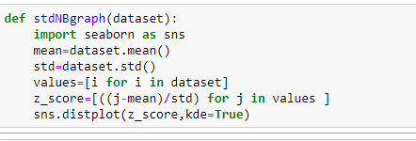

* Create a function stdNBgraph that takes a dataset as input calculates the Z-scores for the dataset.
* Plots a distribution plot using Seaborn.
* Imported Seaborn library. It’s used in the function.
* Values renamed to Z-scores because it makes sense to store the Z-scores in this list.
* z-score calculation subtracting by the mean from each data point and then dividing by the standard deviation.
* Passed z-scores to sns.distplot to create the distribution plot.
* To create a distribution plot of Z-scores for the given dataset.